Who is eligible?  - Individuals who will be or are pursuing a degree at a Synodical school of their choice, and  - Who are presently members of the Circuit 7 Congregations, and  - Who are enrolled in school full-time, and  - Who intend to enter full time church work upon graduation is eligible for a partial scholarship up to $2,000.  - If student does not complete their course of study for full-time church work, the scholarship committee request the scholarship be repaid.  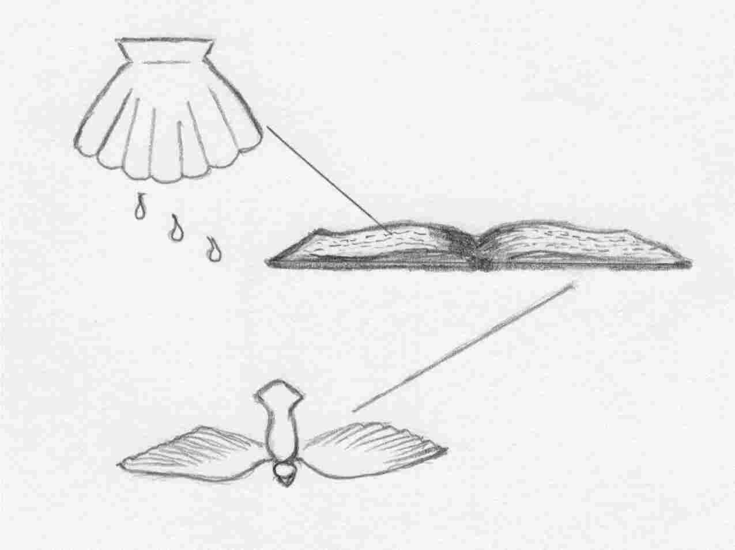 |  |  | Edgar Fajen Memorial Scholarship  Information Pamphlet  For Circuit 7  Kansas District  - Provided by St. John Lutheran Church  - 312 National Road, Palmer, KS 66962  - Phone: 785-692-4228  - e-mail: pastorsherry@bluevalley.net  - website: stjohnpalmer.net  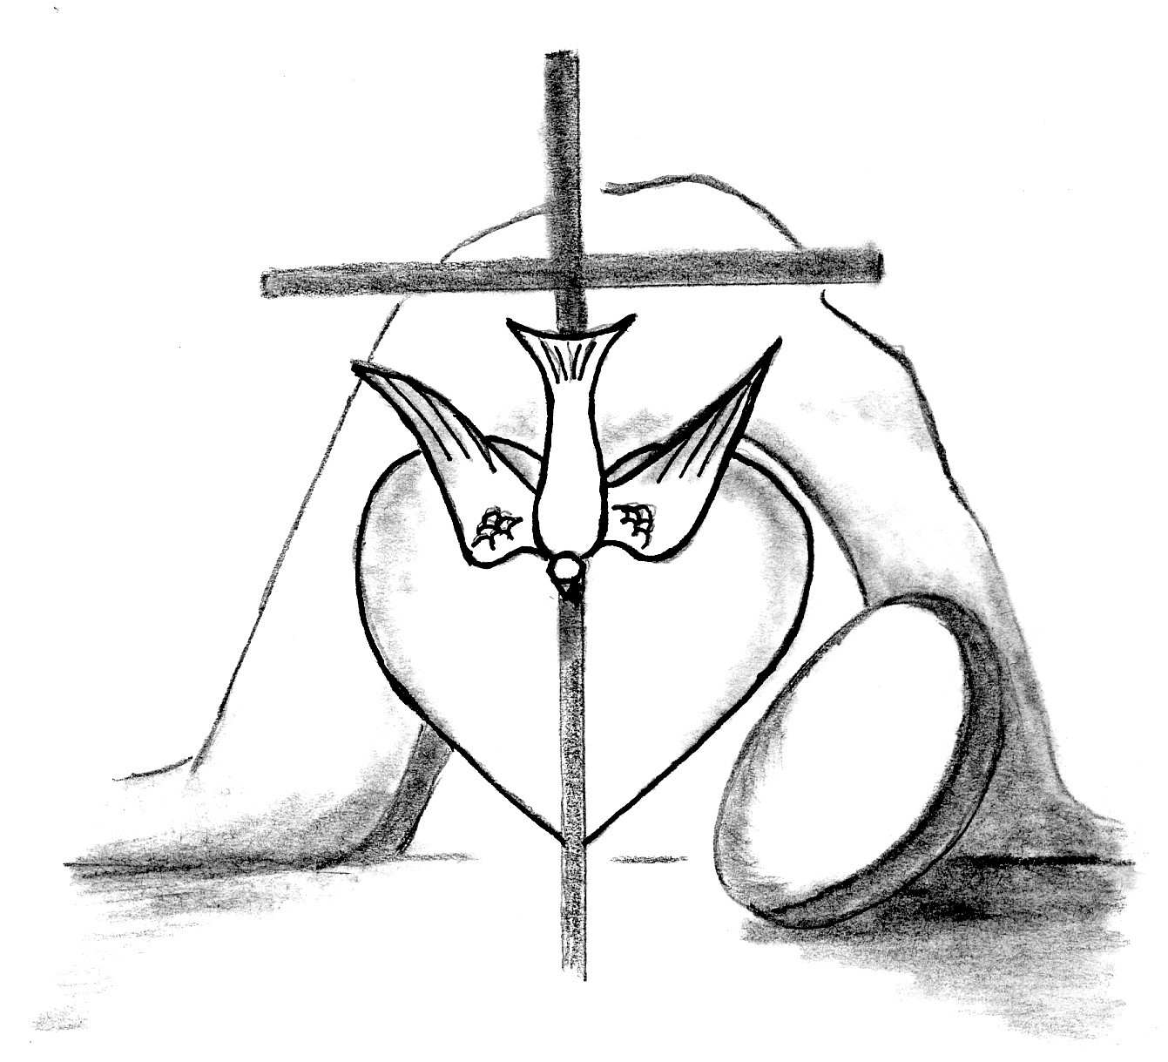

HOW DO I APPLY ….  - Request an application from St. John Lutheran Church (see contact information on front cover of pamphlet) and return it to the St. John Lutheran Church who will pass it on to the scholarship committee chair  - Application may be made anytime during a student’s college career  - Students may apply for up to five years if enrolled in an undergraduate program or up to eight years if studying for the ministry  - All materials should be returned by March 15 prior to the beginning of the school term for which the student desires funding  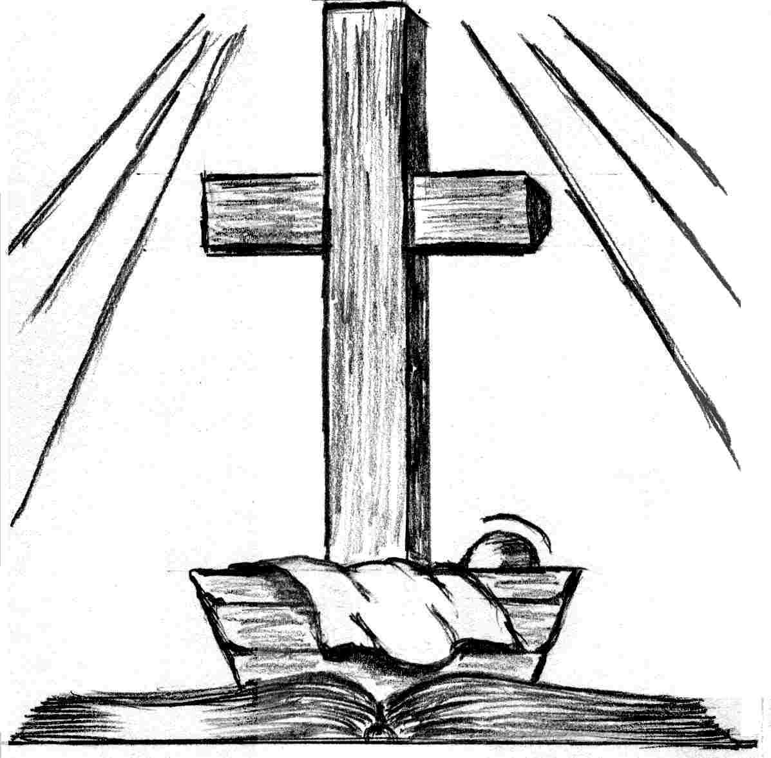 | Circuit 7 Congregations  Trinity Lutheran Church – Afton  Don Dodd, Deacon  Phone: 785-348-5550  e-mail: doddsquad@bluevalley.net  St. Peter Lutheran – Barnes  Bethlehem Lutheran Church – Greenleaf  Matthew Durance, Vacancy Pastor  Phone: 785-747-2407  e-mail: bethlehemgreenleaf@hotmail.com  Bethlehem Lutheran Church - Bremen  Immanuel Lutheran Church – Bremen  Aaron Fenker, Pastor  Phone: 785-337-2402  e-mail: revfenker@gmail.com  St. Paul Lutheran Church – Clay Center  Paul Tessaro, Pastor  Phone: 785-632-5301  e-mail: revpt@juno.com  Trinity Lutheran Church – Hanover  Rodney Fritz, Pastor  Phone: 785-337-2665  e-mail: rdftlc@kansas.net  Immanuel Lutheran Church – Linn  Richard Rikli, Pastor  Phone: 785-348-5892  e-mail: riklir@csl.edu  Zion Lutheran Church – Linn  David Gruoner, Pastor  Phone: 785-348-5332  e-mail: zionlinn@bluevalley.net  Mt. Calvary Lutheran Church – Marysville  Philip Miller, Pastor  Phone: 785-562-2046  e-mail: pastorphilipmiller@gmail.com  St. John Lutheran Church – Palmer  Jacob Sherry, Pastor  Phone: 785-692-4228  e-mail: pastorsherry@bluevalley.net | HOW AND WHEN SELECTION WILL BE MADE….  - Preliminary application review and recommendations will be made by the five-member Fajen Fund committee of St. John Lutheran Church Palmer  - The Church Council of St. John Lutheran Church shall make final approval of the distribution of funds at their scheduled meeting and reported to the Voters Assembly at the regularly scheduled April meeting  - Applicants should be notified of awards by May 1 of the year awarded  - Scholarship funds should be available by August 1 of the year awarded

